Grade 4, Week 35
Kim Đồng Primary School
Student’s name:……………………………
Class:………………………………….
Review
1. Look and write the missing letter
young handsome pretty short tall shy friendly fat

 |  | 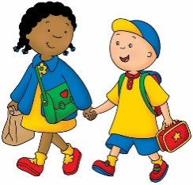 | 
you _ _ | sho _ _ | fr _ _ndly | ta _ _
 |  |  | 
_ _ etty | f _ _ | s _ _ | hands _ _ _

2. Look and Circle
I wasn’t/ weren’t at school last week.

It was/were cold last night.
David wasn’t/weren’t happy yesterday.

My friends was/were in the park this afternoon.
She was/were fat when she was young.

We wasn’t /weren’t hungry.

My friends was/were happy yesterday.

Nicky was/were at the zoo yesterday.

3.Write was or were.

- I …………… happy. | - You …………… angry
- It…………… cold. | - We …………… at school
- I …………… bored. | - You…………… very busy on Friday.
- I…………… a fast runner. | - We…………… happy together.
- He……………our teacher. | - My dog…………… sick last night.
- You……………always a nice person. | - She…………… sleepy yesterday.
- Javier and Roberto…………… lazy last night. | - Kendra…………… a girl with dark hair and brown eyes.

4.Circle the correct words.

- It is the uglier/ ugliest house in the street.

- Jane is taller /tallest than Helen.

- The blue dress is nicest/nicer than the red dress.

- London is biggest/bigger than Manchester.

- This is the taller/tallest tree in my garden.

- A lion is fastest/faster than a cat.

- Zoe has the heaviest /heavier bag in the class.

- That is the cheaper / cheapest doll in the shop.

- The clown is funnier /funniest than that clown.

- August is the hotter /hottest month of the year.

- January is the colder/coldest month of the year.

The end

